Anhang: 3D Dxf Katalog zu Seminarnotizen
Stand: Version 12.1 – Mai 2019 (ohne Cars, Emergency Vehicles und Trains)
Alle 3D Dxf anzeigen: im Windows-Explorer "C:\Program Files (x86)\PCCrash121\3DDxf\DirectX" > Ordner DirectX auswählen > suchen nach *.jpg, Liste wird angezeigt, > rechte Maustaste auf ein Icon: Eigenschaften > Name wird angezeigt unter „Ort“ (Cursor nach hinten schieben)
(ab Version 10.0 ist eine Datei „3ddxf“.pdf in o. g. Ordner hinterlegt, ist aber nicht immer ganz aktuell)

Agricultural > Equipment:
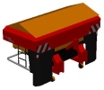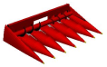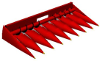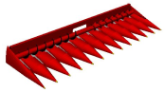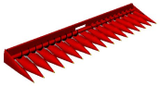
Amazone Corn Head 4,5m Corn Head 6m Corn Head 9m Corn Head 12m
Centrifugal Spreader

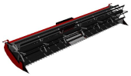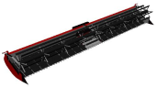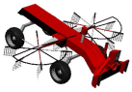
Cutting Platform 9m Cutting Platform 12m Hay Tedder Plow

Agricultural > Harvester:
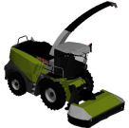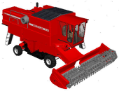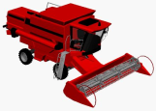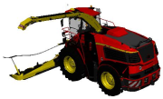
Claas Jaguar Combine New Holland John Deere Combine John Deere 9000
Forage Harvester Harvester Harvester Harvester

Agricultural > Tractor:
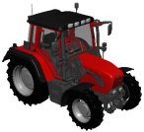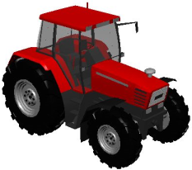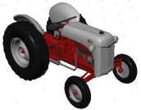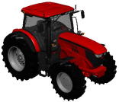
Fendt 312 Fendt 509 Ford 8N John Deere 6210R

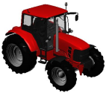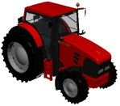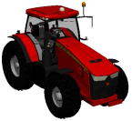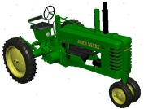
John Deere 6330 John Deere 7530 John Deere 8360r John Deere B

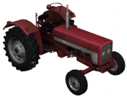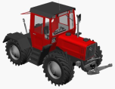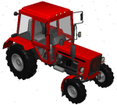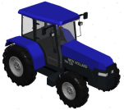
Lizard Mercedes MB Trac MTZ-80 New Holland
900 Turbo

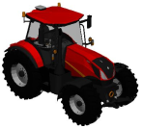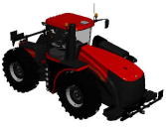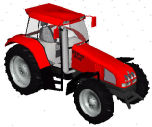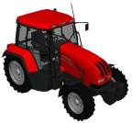
New Holland T7 New Holland T9 Steyr 9145 Steyr CVT 170

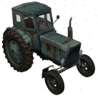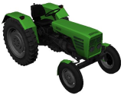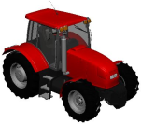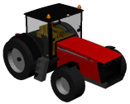
T40 Torpedo Tractor_01 Tractor_02

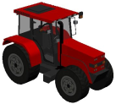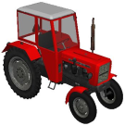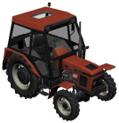
Tractor_03 Ursus C-330 Zetor 5340

Agricultural > Trailer:
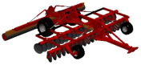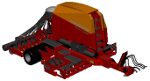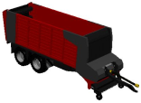
Amazone Compact Amazone Dual-purpose wagon
Disc Harrow Pneumatic Seeder 2-axle

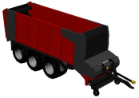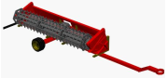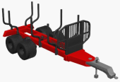
Dual-purpose wagon John Deere Junkkari
3-axle Harvester Trailer Forestry Trailer

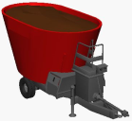
KD710

Animals:
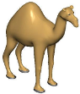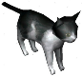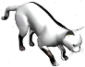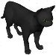
Blackboar walking Bunny Camel Cat_01 Cat_02 Cat_03

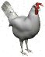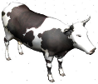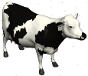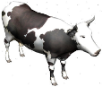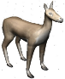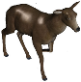
Chicken Cow_01 Cow_02 Cow_02 walking Deer Deer Hind walking

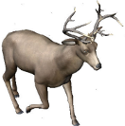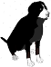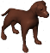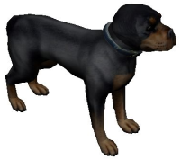
Deer Stag walking Dog_01 Dog_02 Dog_03

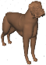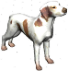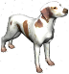
Dog_Boxer Dog_Braco Dog_Braco walking

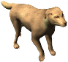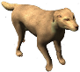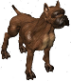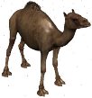
Dog_Golden Retriever Dog_Golden Retriever walking Dog_Pitbull Dog_Pitbull walking Dromedar

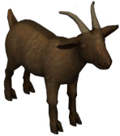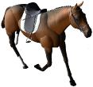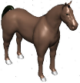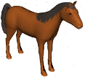
Duck Goat Horse walking Horse_01 Horse_02

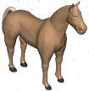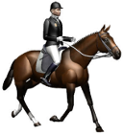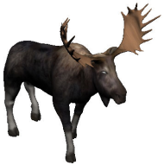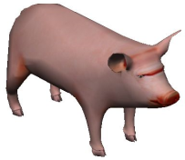
Horse_03 Horse_Rider walking Moose walking Pig

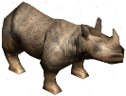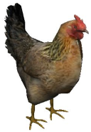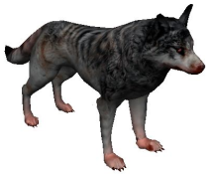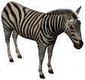
Rhino Rooster Turkey Wolf Zebra

Bicycles:
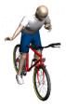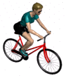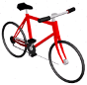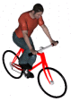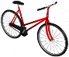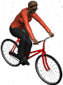
Bicyclist_01 Bicyclist_02 Bike_01 Bike_01 with man Bike_02 Bike_02 with woman

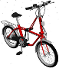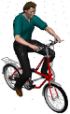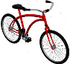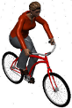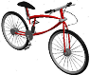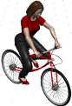
Bike_03 Bike_03 with man Bike_04 Bike_04 with woman Bike_05 Bike_05 with woman

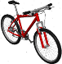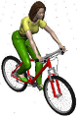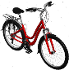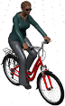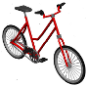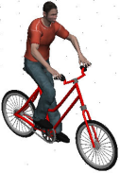
Bike_06 Bike_06 with woman Bike_07 Bike_07 with woman Bike_08 Bike_08 with man

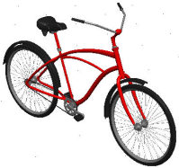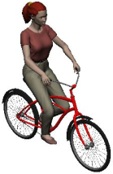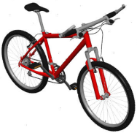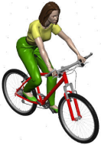
Bike_09 Bike_09 with woman Bike_10 Bike_10 with woman

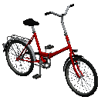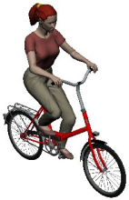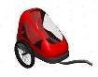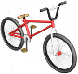
Bike_11 Bike_11 with woman Biketrailer for Kids BMX
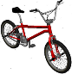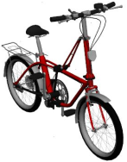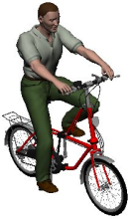
BMX Noxon BMX Noxon BMX Noxon Jump
Jump Jump high high with man

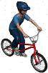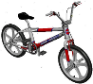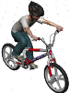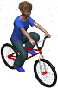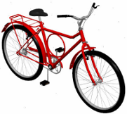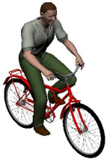
BMX Noxon Jump BMX Skyway BMX Skyway BMX Caloi Barra Forte Caloi Barra Forte
with boy with boy with boy with man

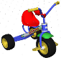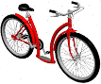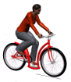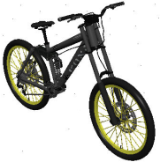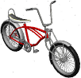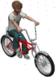
Child trike Citybike Citybike with woman Kona Lowrider bicycle Lowrider bicycle with boy

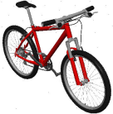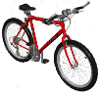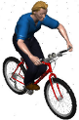
Mountainbike Mountainbike Mountainbike
Trek 800 Trek 800 with man

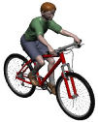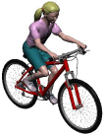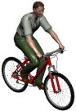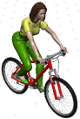
Mountainbike Mountainbike Mountainbike Mountainbike
with boy with girl with man with woman

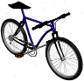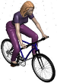
Mountainbike_01 Mountainbike_01
with woman

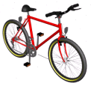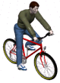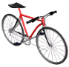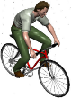
Mountainbike_02 Mountainbike_02 Mountainbike_03 Mountainbike_03
with man with man

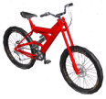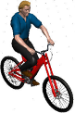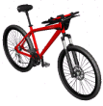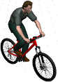
Mountainbike_04 Mountainbike_04 Mountainbike_05 Mountainbike_05
with man with man
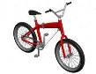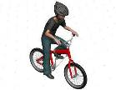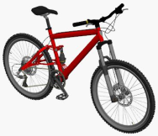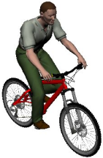
Mountainbike_06 Mountainbike_06 Mountainbike_07 Mountainbike_07
with boy with man

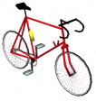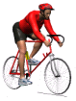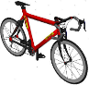
Racing bike_01 Racing bike_01 with man Racing bike_02
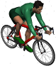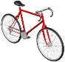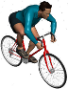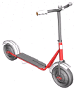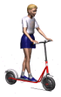
Racing bike_02 with man Racing bike_03 Racing bike_03 with man Scooter Scooter with boy

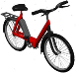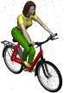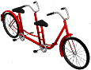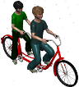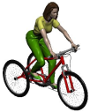
Solex Solex with woman Tandem Tandem with boys Tribike with woman

Buses:
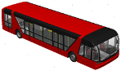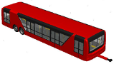
Airportshuttle front Airportshuttle rear

Buses > Public Buses:
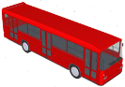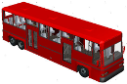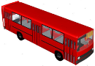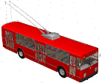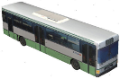
Bus_01 Bus_02 Bus_03 Bus_04 Bus_05

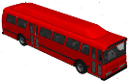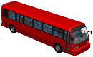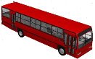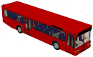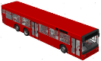
Bus_06 Bus_07 Bus_08 Bus_09 Bus_10

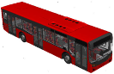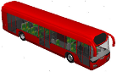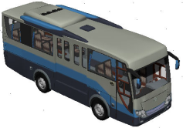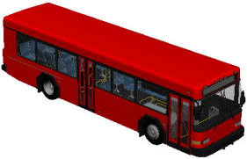
Bus_11 Bus_12 Bus_13 Bus_14

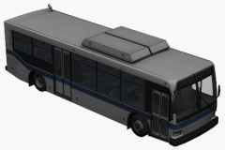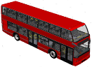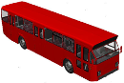
CATS City Bus DAF Double-Decker DAF_01

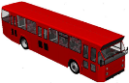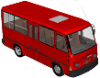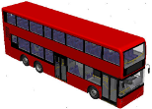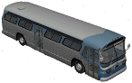
DAF_02 Deutz Double-Decker GM 1969

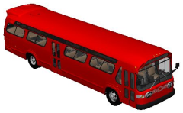
GM TDH 5303

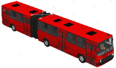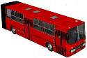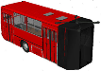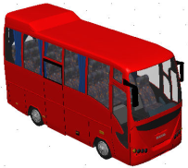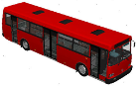
Ikarus 280 Ikarus 280 front Ikarus 280 rear Iveco Eurocity LAZ

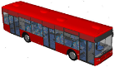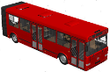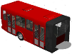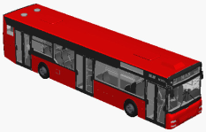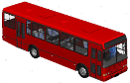
LAZ A 183 Liaz 6212 front Liaz 6212 rear MAN Lion City Marcopolo

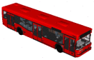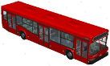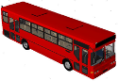
MAZ MAZ 103 Mercedes

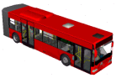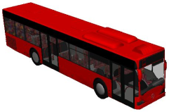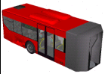
Mercedes Citaro front Mercedes Citaro G Mercedes Citaro rear

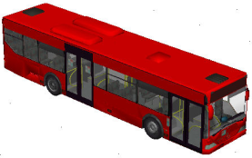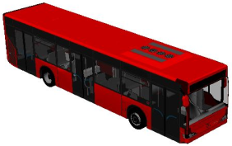
Mercedes Citaro_01 Mercedes Citaro_02

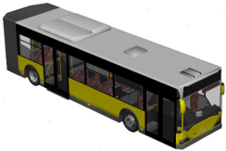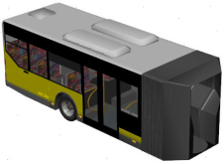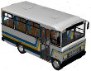
Mercedes G front Mercedes G rear Mercedes LO608D

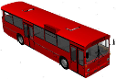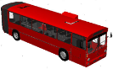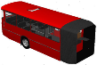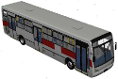
Mercedes O305 Mercedes O305 G Mercedes O305 G Mercedes Transpasso
Front rear
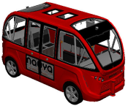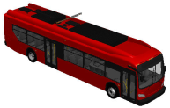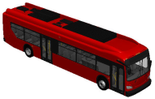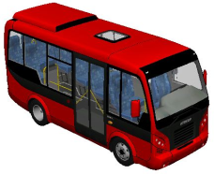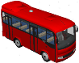
Navya Arma New Flyer Xcelsior New Flyer Xcelsior Otokar Magirus Otokar Sultan 125L
autonom shuttle Electric Bus 2016 NonElectric Bus 2016 M-2010

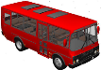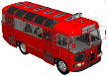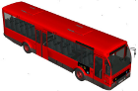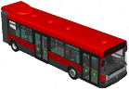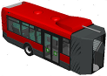
PAZ PAZ 672 Public Transport Renault Agora front Renault Agora rear
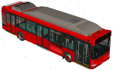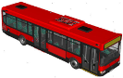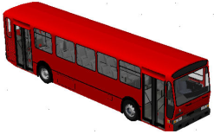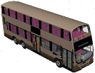
Renault GNV Renault Line RATP Rocar De Simon Volvo B10TL

Weitere Buses:

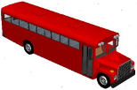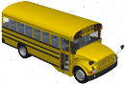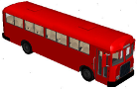
Schoolbus_01 Schoolbus_02 Schoolbus_03

Travel Buses:
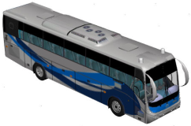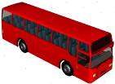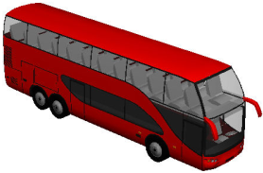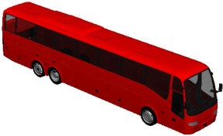
Aga Solaris Mercedes Benz Bus_01 Bus_02 Bus_03

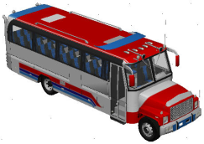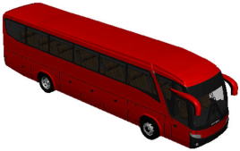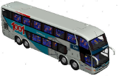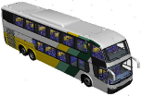
Kodiak B70 Marcopolo Paradiso 1200 Marcopolo Paradiso Marcopolo Paradiso
1800 G6 8x2 G6 6x2

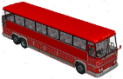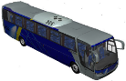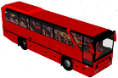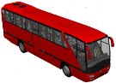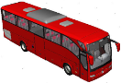
MCI MC9 Mercedes Busscar Mercedes O403_01 Mercedes O403_02 Merc. Tour. 16 RHD

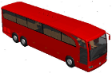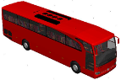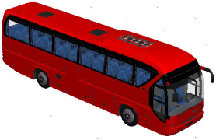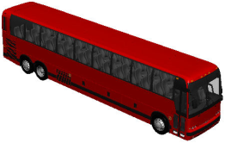
Mercedes Travego_01 Mercedes Travego_02 Neoplan Tourliner Prevost X3-45 2011

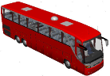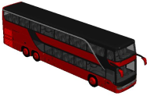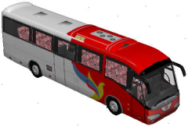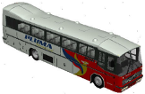
Setra S 417 HDH Setra S 431 2013 Volvo 9700 Volvo Nielson Diplomata

Camping:
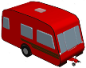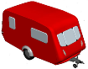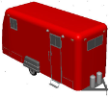
Campingtrailer Campingtrailer 5m Campingtrailer 6,5m

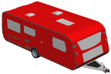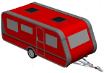
Campingtrailer 7,5m Campingtrailer 7m

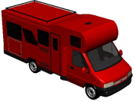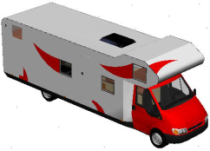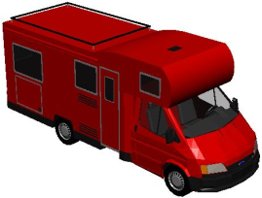
Campmobile Campmobile Campmobile
Fiat Ducato Ford Transit Ford Transit 5,5m

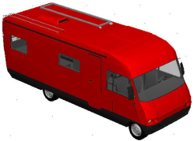
Campmobile
Hymer

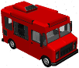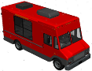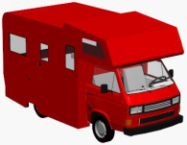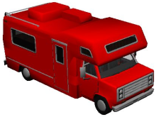
Campmobile_01 Campmobile_02 Campmobile_03 Campmobile_04

Cars: Auswahl über PC-Crash

Construction:
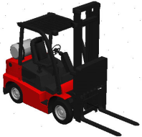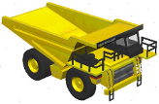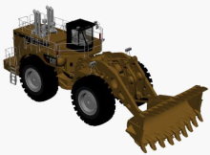
- Cat Forklift Caterpillar 775 Caterpillar 994F

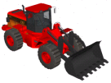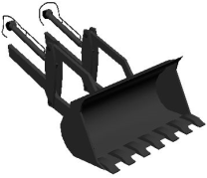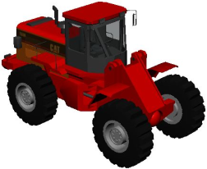
Caterpillar T530 Caterpillar T530 Caterpillar T530
Bucket without Bucket

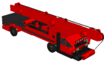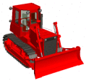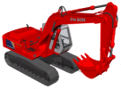
Crane Crawler Fiat Hitachi

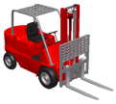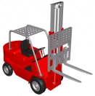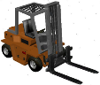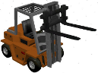
Forklift_01 Forklift_01 Forklift_02 Forklift_02
Forklift down Forklift up Forklift down Forklift up

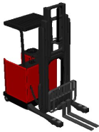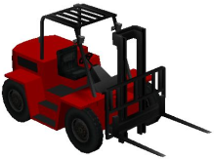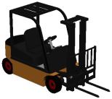
Forklift_03 Forklift_04 Forklift_05

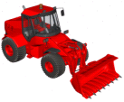
JBC 435

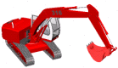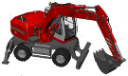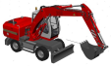
Liebherr 316 Liebherr 316 Liebherr 316
Excavator Excavator wheeled Excavator wheeled 02

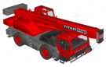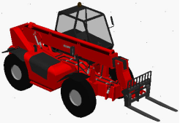
MAN LTM Manitou
telescopic handler

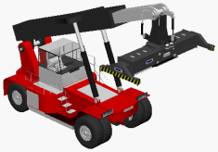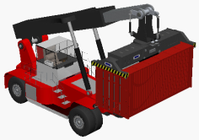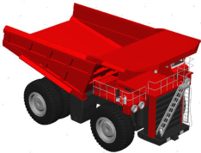
Reach Stacker Reach Stacker Terex MT 4400
with Container Dump Truck

Emergency Vehicles: Auswahl über PC-Crash

Houses > Barn:
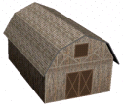
Barn 13m

Houses > Buildings:
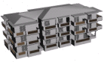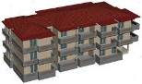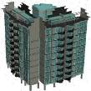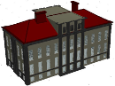
Building 26m Building 28m Building 30m Building 32m

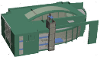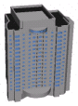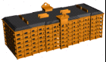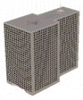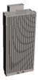
Building 42m Building 50m Building 68m Building 72m Building 75m

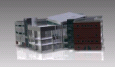
Campus 52m

Houses > Bungalow:
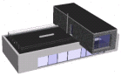
Bungalow 22m

Houses > Garages:
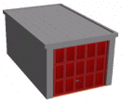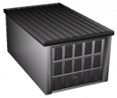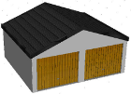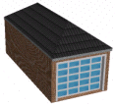
Garage 5,6m_01 Garage 5,6m_02 Garage 6,5m Garage 6m

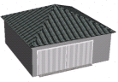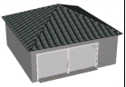
Garage 8m Garage 8m open

Houses > Gazebo:
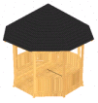
Gazebo 4m

Houses > Houses:
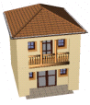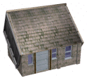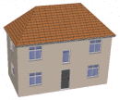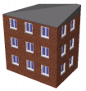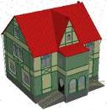
House 7m House 8m House 10m_01 House 10m_02 House 10m_03

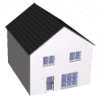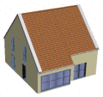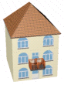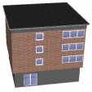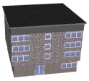
House 11,5m House 11m_01 House 11m_02 House 11m_03 House 11m_04

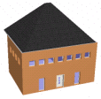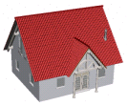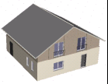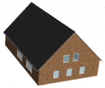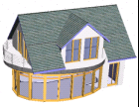
House 11m_05 House 12m_01 House 12m_02 House 12m_03 House 12m_04

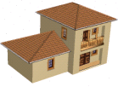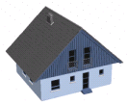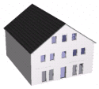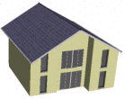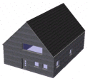
House 12m_05 House 13m_01 House 13m_02 House 13m_03 House 13m_04

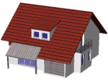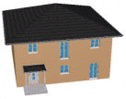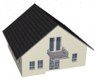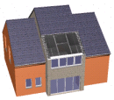
House 13m_05 House 13m_06 House 13m_07 House 13m_08

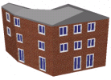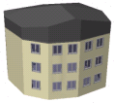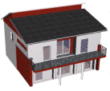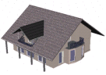
House 13m_09 House 13m_10 House 13m_11 House 13m_12

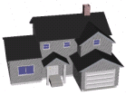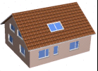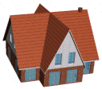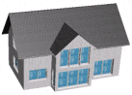
House 14m_01 House 14m_02 House 14m_03 House 14m_04

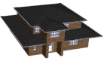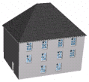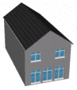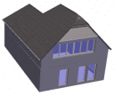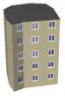
House 14m_05 House 14m_06 House 14m_07 House 14m_08 House 15,5m

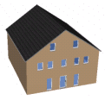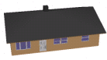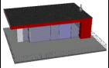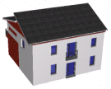
House 15m_01 House 15m_02 House 15m_03 House 15m_04

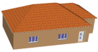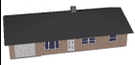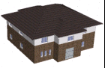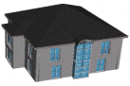
House 15m_05 House 16m_01 House 16m_02 House 16m_03

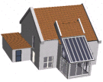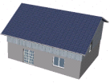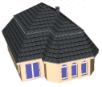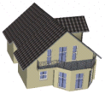
House 16m_04 House 16m_05 House 16m_06 House 16m_07

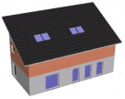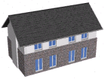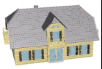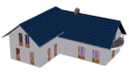
House 17,5m_01 House 17.5m_02 House 17m_01 House 17m_02

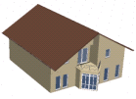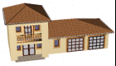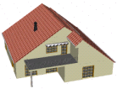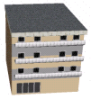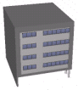
House 17m_03 House 17m_04 House 17m_05 House 17m_06 House 17m_07

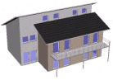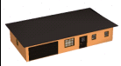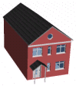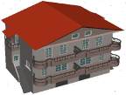
House 17m_08 House 18m_01 House 18m_02 House 18m_03

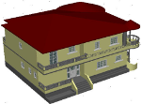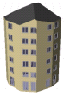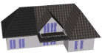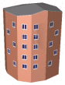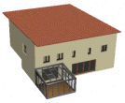
House 18m_04 House 19m_01 House 19m_02 House 19m_03 House 19m_04

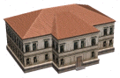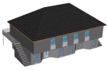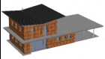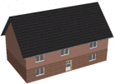
House 20m_01 House 20m_02 House 20m_03 House 20m_04

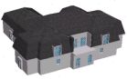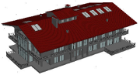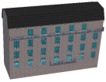
House 23m House 26m House 28m

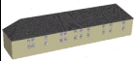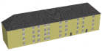
House 46m_01 House 46m_02

Human:
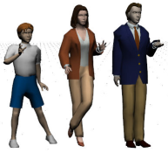
Family

Human > Female
Girl_01 Girl_02 Old woman Woman_01 Woman_02 Woman_03 Woman_04 Woman_05

Woman_06 Woman_07

Human > Male
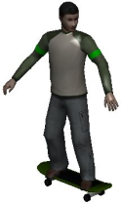
Boy_01 Boy_02 Man Man_01 Man_02 Man_03 Man_04
with Skateboard
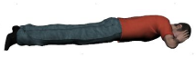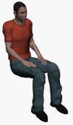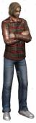
Man_Lying Man_Sitting Old man Passenger_Sitting Young man

Human > People Animated:
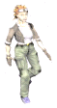
Animated Ped. MS Woman Boy 02 walking Boy running Boy walking female 01 female 02

Female 03 running Female 03 walk.var.clothes Female 03 walking female 04 running female 04 walking

male 02 male 02 running male 02 walking Male 03 running Male 03 walking male 04

Male 05 walking Male 06 running Male 06 walking Old man walking Old woman walking

Human > Skier:

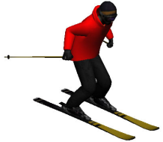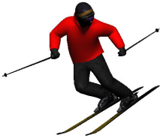
Skier Parallel Skier Stop
Still Pose Still Pose

Misc > Aircraft:
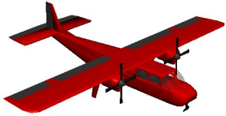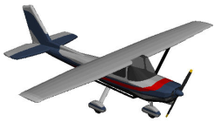
Beagle Cessna172

Weitere Misc:
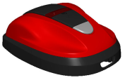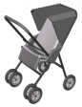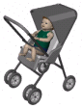
Automatic Lawnmower Baby Buggy Baby Buggy+Baby

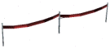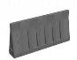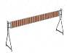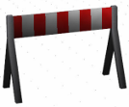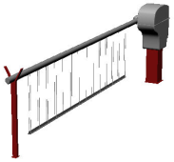
Barrier_01 Barrier_02 Barrier_03 Barrier_04 Barrier_05

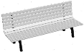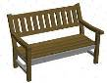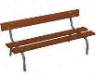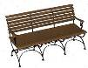
Bench_01 Bench_02 Bench_03 Bench_04

Misc > Boats:
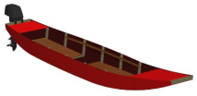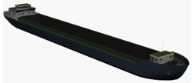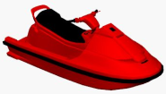
Barge Inland Cargo Ship Jetski

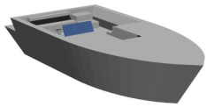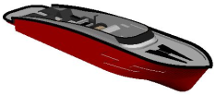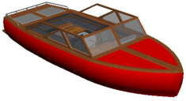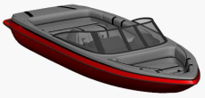
Motorboat_01 Motorboat_02 Motorboat_03 Motorboat_04

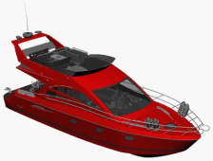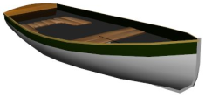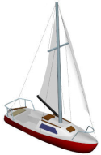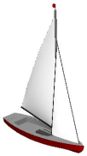
Motorboat_05 Rowboat Sailing boat_01 Sailing boat_02

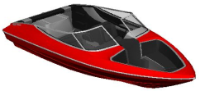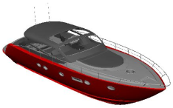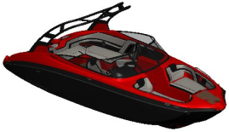
Speedboat Yacht Yamaha

Weitere Misc:
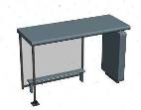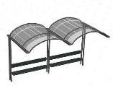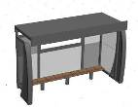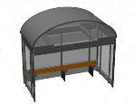
Bus Stop_01 Bus Stop_02 Bus Stop_03 Bus Stop_04

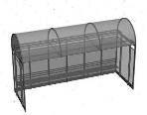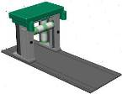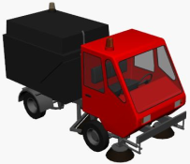
Bus Stop_05 Car Wash Compact Street Sweeper

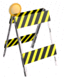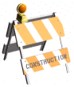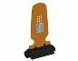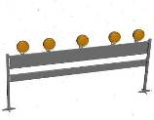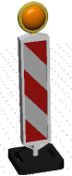
Construction_01 Construction_02 Construction_03 Construction_04 Construction_05

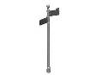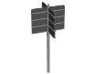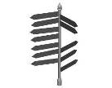
Container Direction Sign_01 Direction Sign_02 Direction Sign_03 Direction Sign_04

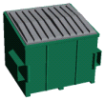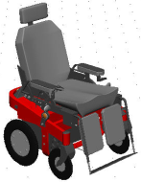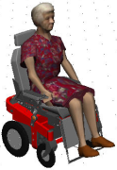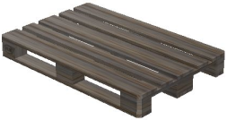
Dumpster Electric wheelchair Electric wheelchair Euro Pallet
with old woman

Misc > Fences > Doors:
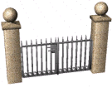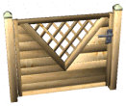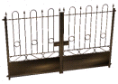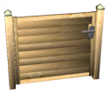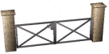
Door_01 Door_02 Door_03 Door_04 Door_05

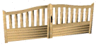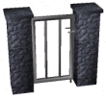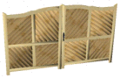
Door_06 Door_07 Door_08

Misc > Fences:
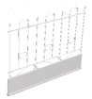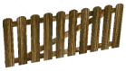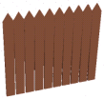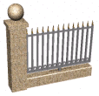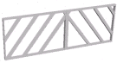
Fence_01 Fence_02 Fence_03 Fence_04 Fence_05 Fence_06

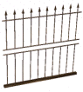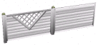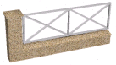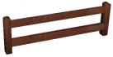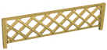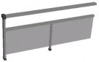
Fence_07 Fence_08 Fence_09 Fence_10 Fence_11 Fence_12

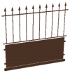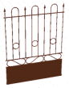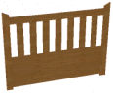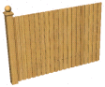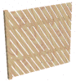
Fence_13 Fence_14 Fence_15 Fence_16 Fence_17

Weitere Misc:
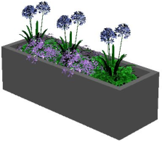
flower trough_01 flower trough_02 flower trough_03 flowerbox

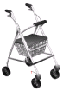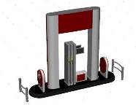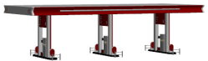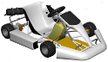
Four-Wheel Walker Gas Station_01 Gas Station_02 Go-Kart

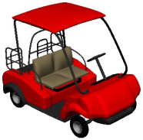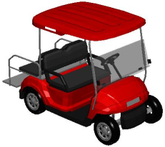
Golf cart_01 Golf cart_02

Misc > guardrail:
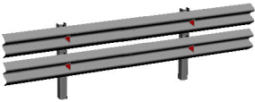
center Complete double guardrail

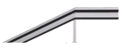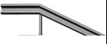
end_left end_right single guardrail

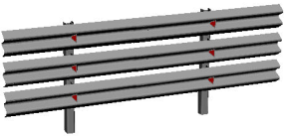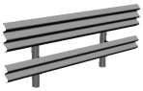
triple guardrail triple wave

Weitere Misc:

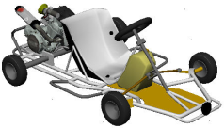
Hayabusa Kart (findet sich derzeit, wohl versehentlich, unter”Hydrant”)

Misc > Highway signs:
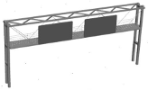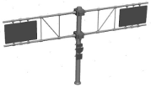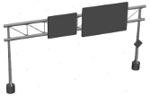
01 02 03 04

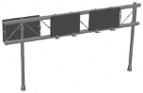
05 06

Weitere Misc:
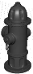
Hydrant

Misc > Lamps:

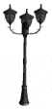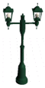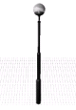
Lamp_01 Lamp_02 Lamp_03 Lamp_04 Lamp_05 Lamp_06 Lamp_07 Lamp_08 Lamp_09 Lamp_10 Lamp_11

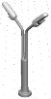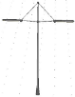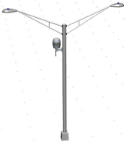
Lamp_12 Lamp_13 Lamp_14 Lamp_15

Weitere Misc:

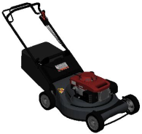
Lawn mower

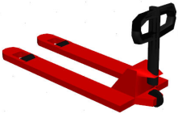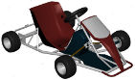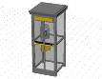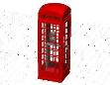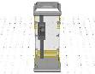
Pallet Jack Pedal Car Phone box_01 Phone box_02 Phone box_03

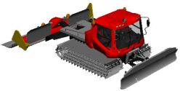
PistenBully400P

Misc > Poles:
Pole 2,5m Pole 3m
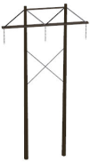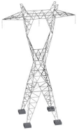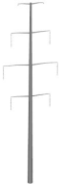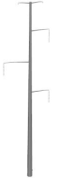
Power pole Power pole Power pole Power pole Power pole Power pole Power pole
6,5m 8m 11m 13m 30m_01 30m_02 30m_03

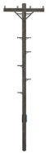
Telegraph pole Telegraph pole
6,8m 10,5m

Weitere Misc:

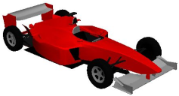
Racing car

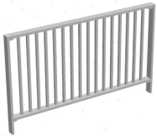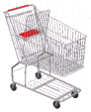
Railing Rock Shopcart_01 Shopcart_02

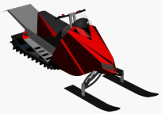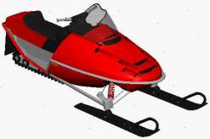
Snowmobile Arctic Cat Snowmobile Polaris

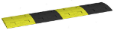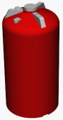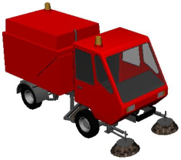
Speed Bump_ Storage Tank Sweeper

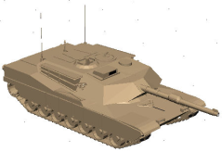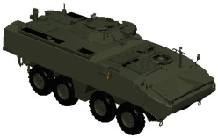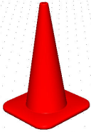
Tank M1 Abrams Tank Piranha IIIC Traffic Cone Traffic Cone 0.5m

Misc > Traffic Lights:
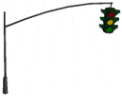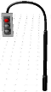
Pedestrian Pedestrian Traffic Light Traffic Light_ Traffic Light
light (green) light (red) hanging_01 hanging_02

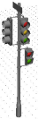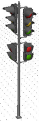
Traffic Light Traffic Light Traffic Light Traffic Light Traffic Light
Japan standing_01 standing_02 standing_03 standing_04

Misc > Traffic Signs > A - Danger:

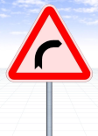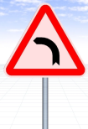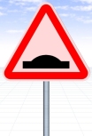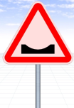
A1a Right bend A1b Left bend A1c Double bend A1d Double bend A2a Road bump A2b Depression

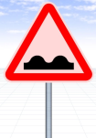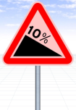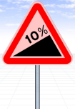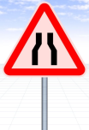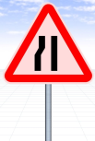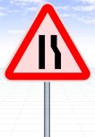
A2c Uneven road A3a Steep A3b Steep A4a Road narrows A4b Road A4c Road
descent ascent both sides narrows left narrows right

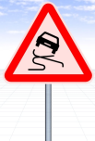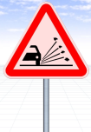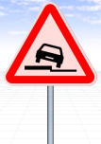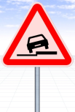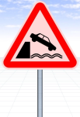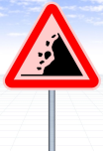
A5 Slippery A6 Loose A7a Low A7b Low A8 Unprotected A9 Falling rocks
road surface road surface shoulder shoulder quayside or riverbank

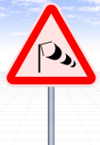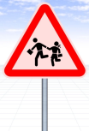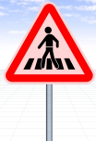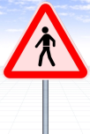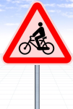
A12 Dangerous A14 Children A16a Pedestrian A16b Pedestrians A17 Cyclists A22 Traffic signals
crosswinds crossing ahead ahead

A23 Roadworks A24 Crossroads with A25 Two way traffic A29 Other danger
ahead priority to the right ahead

Misc > Traffic Signs > B – Give Way:

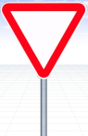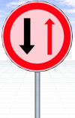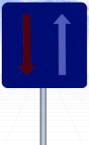
B1 Give way B2 STOP B3 Priority road B4 End of B5 Give way to B6 Priority over
priority road oncoming traffic oncoming vehicles

B7 Roundabout B8 Crossroads with B9a Junction with B9b Junction with
ahead a minor road a minor side road a minor side road

B9c Junction with B9d Junction with
a minor side road a minor side road

Misc > Traffic Signs > C - Prohibitory:

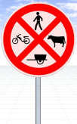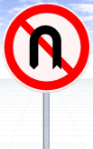
C1 No entry for C2 Road closed C4e Transito proibido C11a Proibicao C11b No right turn C12 No left turn
Vehicular traffic to all vehicles

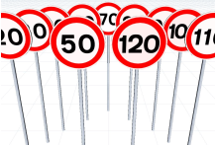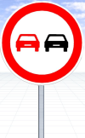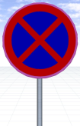
C13 Maximum C14a No C15 No parking C16 No stopping
speed limit overtaking and parking

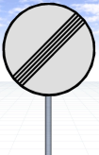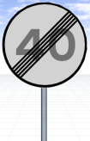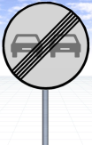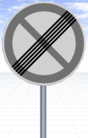
C20a End of C20b End of C20c End of C21 End of
prohibition speed limit no overtaking no parking

Misc > Traffic Signs > D - Mandatory:

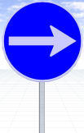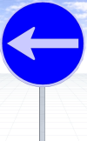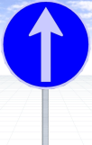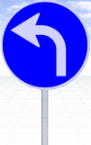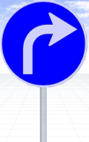
D1a Turn right D1b Turn left D1c Proceed D1d Turn D1e Turn D2a Proceed
straight left ahead right ahead straight or turn left

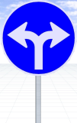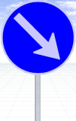
D2b Proceed D2c Proceed D3a Keep D3b Keep D4 Roundabout
straight or turn right left or right right left

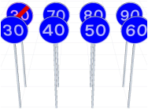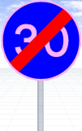
D8 Minimum D14 End of minimum
speed limit Speed limit

Misc > Traffic Signs > H - Information:

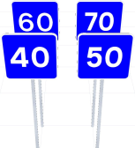
H1a Parking H2 Hospital H3 One way H4 No trough H6 Recommended
place street road velocity

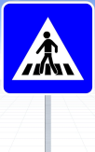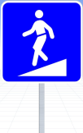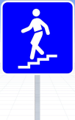
H7 Pedestrian H8a Pedestrian H8b Pedestrian H24 Motorway H27 Turn
crossing subway subway around

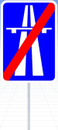
H29a Portugal H37 End of H38 End of H40 End of
recommended velocity motorway parking

Misc > Traffic Signs > other:

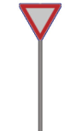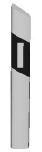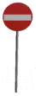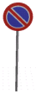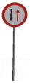
Closed for Give priority Guide post Guide post Guide post No entry No parking Oncoming
all vehicles Germany Germany mirrored traffic

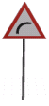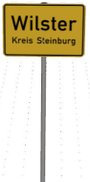
Pass left Pass right Priority Right hand curve Stop Town sign

Weitere Misc:

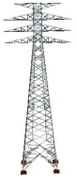
Transmission tower

Misc > Trash Cans:

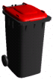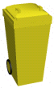
Trash Can_01 Trash Can_02 Trash Can_03 Trash Can_04 Trash Can_05

Trash Can_06 Trash Can_07

Misc > Tunnel:

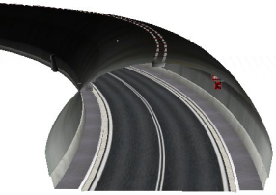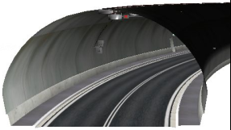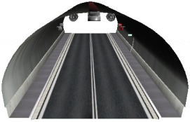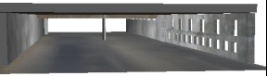
Tunnel01_left Tunnel01_right Tunnel01_straight Tunnel02

weitere Misc:

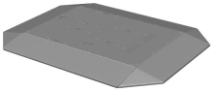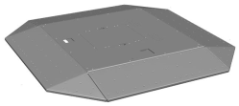
UFO-long UFO_short

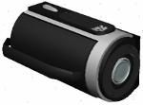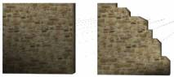
Video Camera Wall_1m Wall_20m

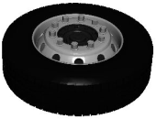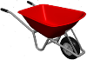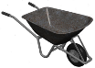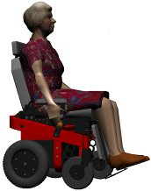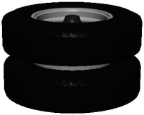
Wheel Wheel Barrow_01 Wheel Barrow_02 Wheel chair elect Wheel double

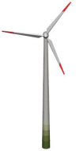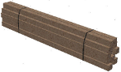
Wind wheel 60m Wood loading

Motorbikes:
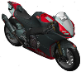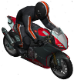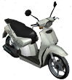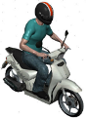
Aprilia RSV4 Aprilia RSV4 Aprilia Scarabeo Aprilia Scarabeo
with driver 50cc 2003 50cc 2003 with driver

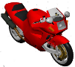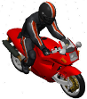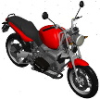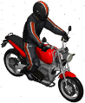
Bimota Bimota with driver BMW 1100 BMW 1100 with driver

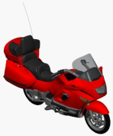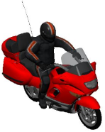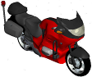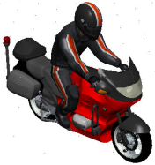
BMW 1200 LT BMW 1200 LT BMW R1150RT BMW R1150RT
with driver with driver

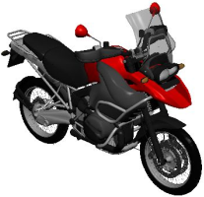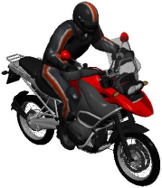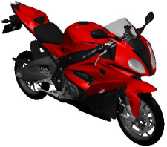
BMW R1200 GS BMW R1200 GS BMW S 1000 RR
2007 2007 with driver
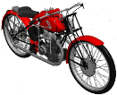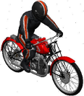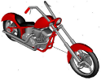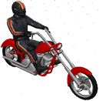
Cagiva Freccia Cagiva Freccia Chopper Chopper with driver
with driver
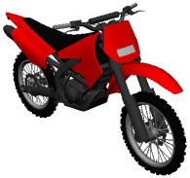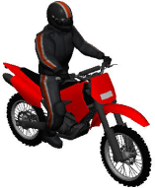
Derbi Senda Derbi Senda
with driver

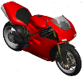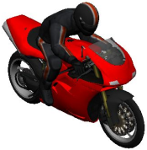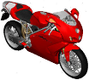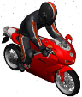
Ducati 998R Ducati 998R Ducati 999R Ducati 999R
with driver with driver
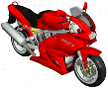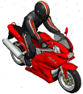
Ducati 1000 DS Ducati 1000 DS with driver

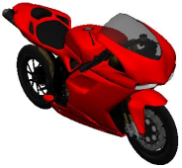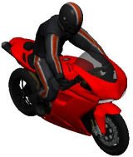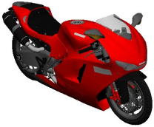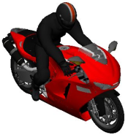
Ducati 1098 2007 Ducati 1098 2007 Ducati Desmosedici Ducati Desmosedici
with driver RR 2012 RR 2012 with driver

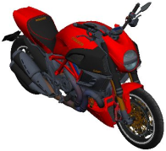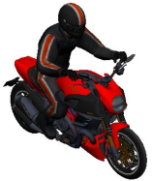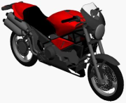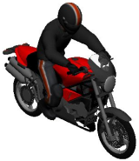
Ducati Diavel Carbon Ducati Diavel Carbon Ducati Monster Ducati Monster
2011 2011 with driver with driver
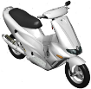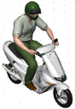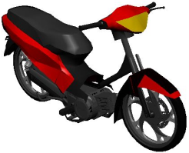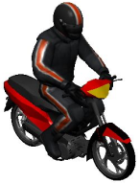
Gilera Runner 50 SP Gilera Runner 50 SP Gilera Smash Gilera Smash
with driver with driver

Motorbikes > Harley Davidson:

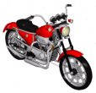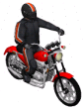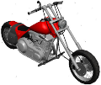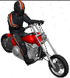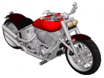
883 883 with driver Black Death Black Death with driver Black Rider

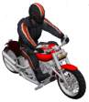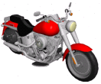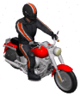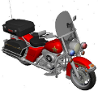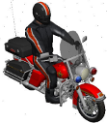
Black Rider with driver Fat Boy Fat Boy with driver FLH 1200 FLH 1200 with driver

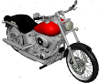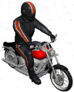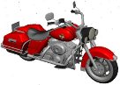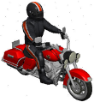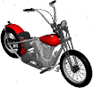
FXSTB FXSTB with driver Road King Road King with driver Shovelhead

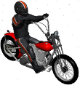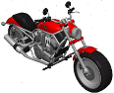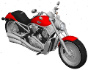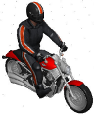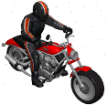
Shovelhead with driver V-Rod V-Rod 2008 V-Rod 2008 with driver V-Rod with driver

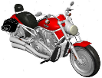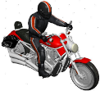
VRSCA V-Rod 2002 VRSCA V-Rod 2002 with driver

Motorbikes > Honda:
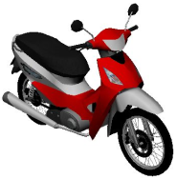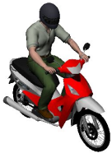
Biz 125 Biz 125 with driver

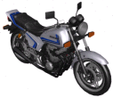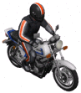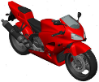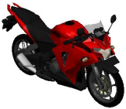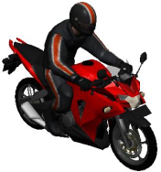
CB750F CB750F CBR CBR 250R CBR 250R
with driver with driver

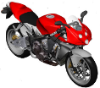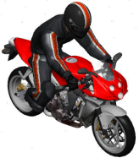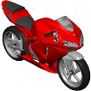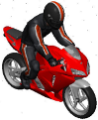
CBR 600 CBR 600 CBR 600RR 2005 CBR 600RR 2005
with driver with driver

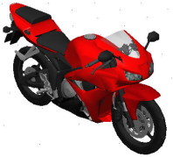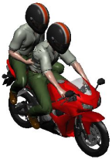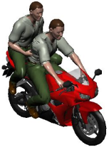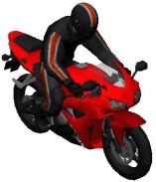
CBR 600RR 2012 CBR 600RR 2012 CBR 600RR 2012 CBR 600RR 2012
with 2 drivers helmeted with 2 drivers un-helmeted with driver

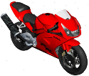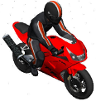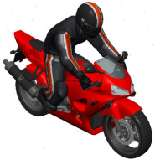
CBR 900 RR CBR 900 RR with driver CBR with driver

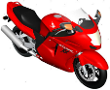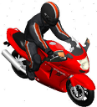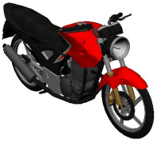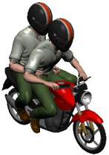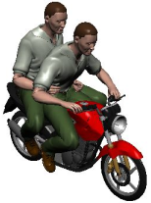
CBR1100 CBR1100 CBX 250 2014 CBX 250 2014 CBX 250 2014
with driver with 2 drivers helmeted with 2 drivers un-helmeted

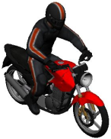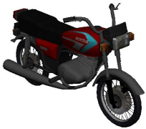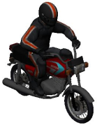
CBX 250 2014 CG 125 CG 125
with driver with driver

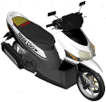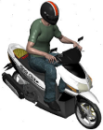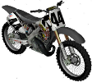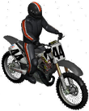
Click Click with driver CR 125 CR 125 with driver

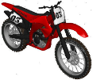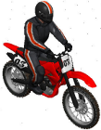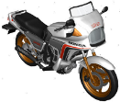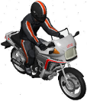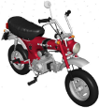
CRF450 CRF450 with driver CX500 CX500 with driver DAX Mofa

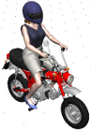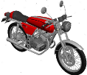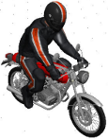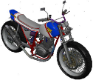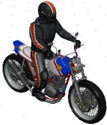
Dax Mofa with driver Dream 50 Dream 50 with driver FTR 223 FTR 223 with driver

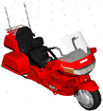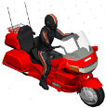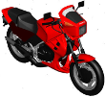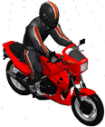
Goldwing Goldwing with driver MVX250F MVX250F with driver

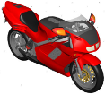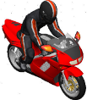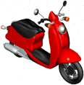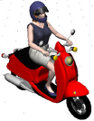
NR NR with driver Scooter Scooter with driver

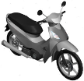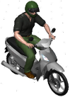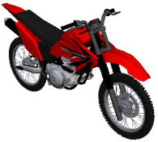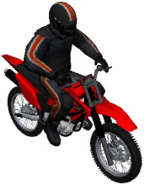
SH 150 SH 150 with driver Tornado Tornado with driver

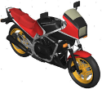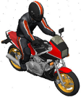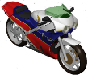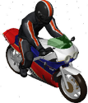
VF750F VF750F with driver VFR 750R VFR 750R with driver

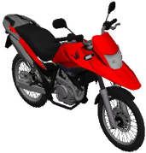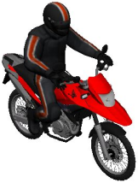
XRE 300 XRE 300 with driver

weitere Motorbikes:
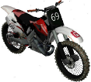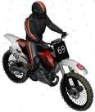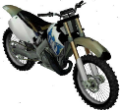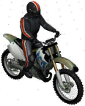
Husqvarna CR 125 Husqvarna CR 125 Husqvarna TC 610 Husqvarna TC 610
with driver with driver

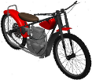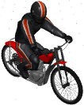
Jawa Jawa with driver

Motorbikes > Kawasaki:

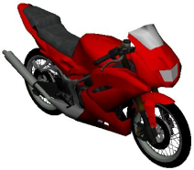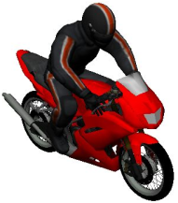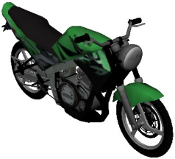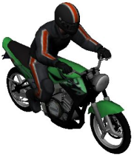
Ninja 150 RR Ninja 150 RR Ninja 150 SS Ninja 150 SS
with driver with driver

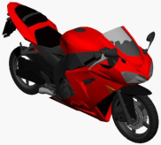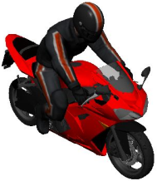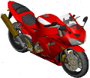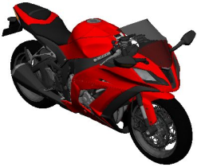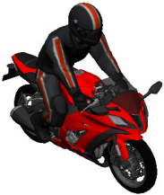
Ninja ZX 6R Ninja ZX 6R Ninja ZX 10R Ninja ZX 10R 2014 Ninja ZX 10R 2014
with driver with driver

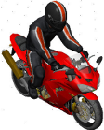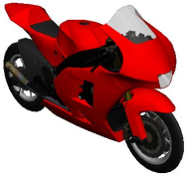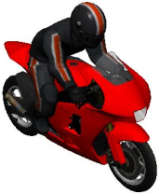
Ninja ZX 10R Ninja ZX RR 2002 Ninja ZX RR 2002
with driver with driver

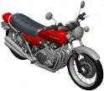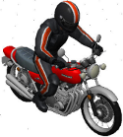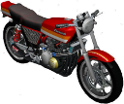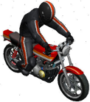
Z1 1975 Z1 1975 with driver Z400 FX Z400 FX with driver

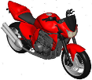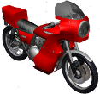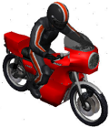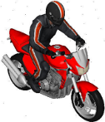
Z1000 Z1000 A1 Z1000 A1 with driver Z1000 with driver

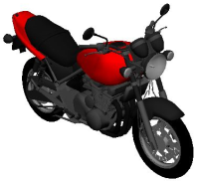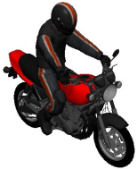
Zephyr Zephyr with driver

weitere Motorbikes:
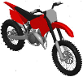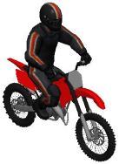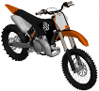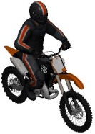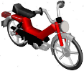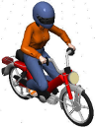
KTM 125 EXC KTM 125 EXC KTM 250 SX KTM 250 SX Mofa Mofa
with driver with driver with driver

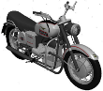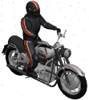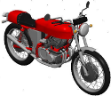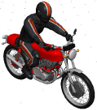
Moto Guzzi V7 2008 Moto Guzzi V7 2008 Moto Guzzi_01 Moto Guzzi_01
with driver with driver

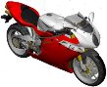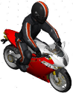
MV Agusta F4 Tamburini MV Agusta F4 Tamburini
with driver
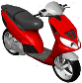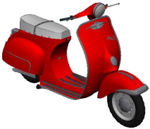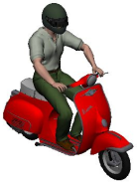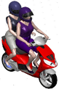
Piaggio Piaggio Vespa Piaggio Vespa Piaggio
180 SS 180 SS with driver with 2 drivers

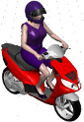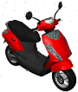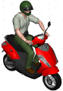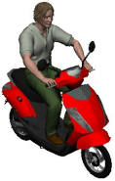
Piaggio with driver Piaggio ZIP Piaggio ZIP Piaggio ZIP
with driver with driver without helmet

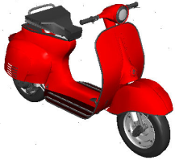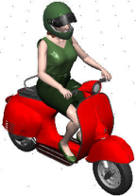
Vespa Vespa with driver

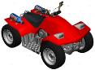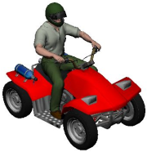
Quad Quad with driver

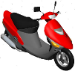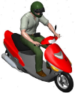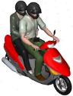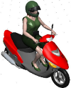
Scooter_01 Scooter_01 man Scooter_01 Scooter_01 woman
two persons

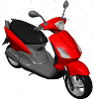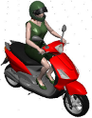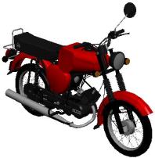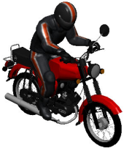
Scooter_02 Scooter_02 Simson S51 1980 Simson S51 1980
with driver with driver

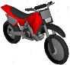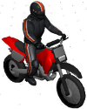
Supermoto Supermoto with driver

Motorbikes > Suzuki:
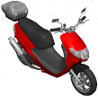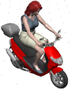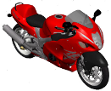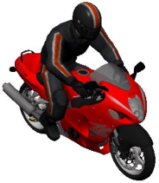
Address 110 Address 110 GSX 1300R Hayabusa GSX 1300R Hayabusa
with driver with driver

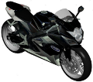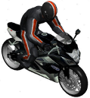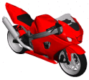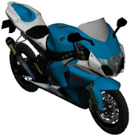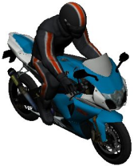
GSX-R 750 GSX-R 750 GSX-R 1000 GSX-R 1000 GSX-R 1000
with driver 2009 2009 with driver

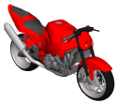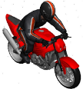
GSX-R 1000 GSX-R 1000 Street Fighter
Street Fighter with driver

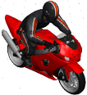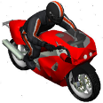
GSX-R 1000 with driver GSX-R with driver

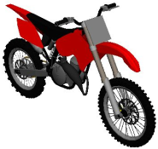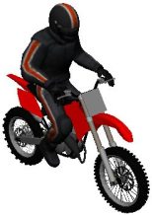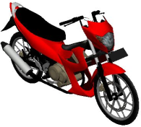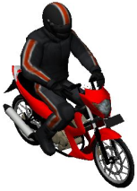
RM-250 RM-250 Satria F150 2013 Satria F150 2013
with driver with driver

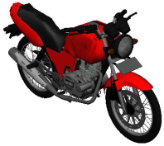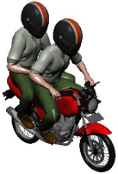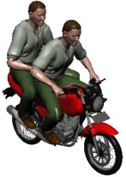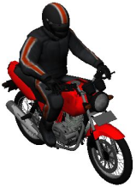
Thunder 125 Thunder 125 with Thunder 125 with Thunder 125
2 drivers helmeted 2 drivers un-helmeted with driver

weitere Motorbikes:
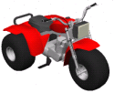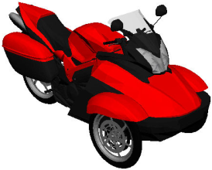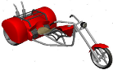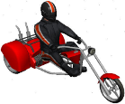
Trike Trike CanAm Trike Chopper Trike Chopper
Spyder with driver

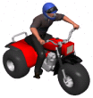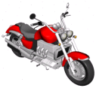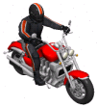
Trike with driver Triumph Rocket 3 Triumph Rocket 3
with driver

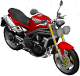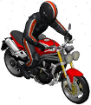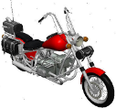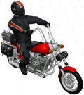
Triumph Speed Triple Triumph Speed Triple Ural Wolf 1998_01 Ural Wolf 1998_01
with driver with driver

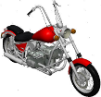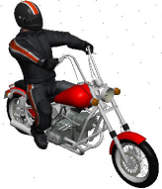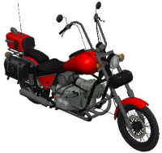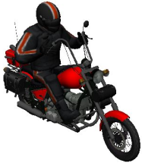
Ural Wolf 1998_02 Ural Wolf 1998_02 Ural Wolf 1998_03 Ural Wolf 1998_03
with driver with driver
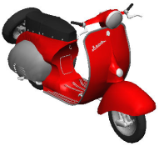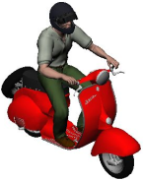
Vyatka Vyatka with driver

Motorbikes > Yamaha:
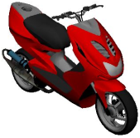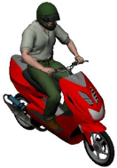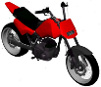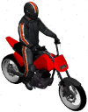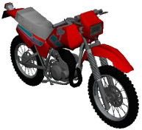
Aerox Aerox with driver DT 180 01 DT 180 01 with driver DT 180 02

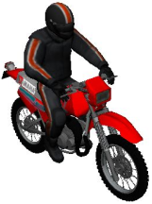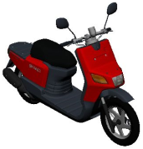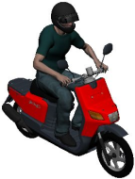
DT 180 02 Gear Gear
with driver with driver

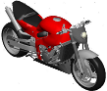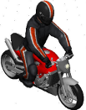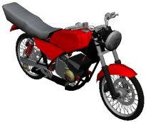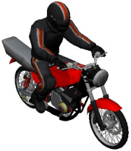
R1 R1 with driver RX 135 RX 135 with driver

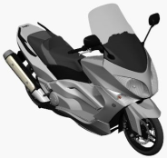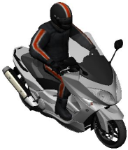
T-Max 2010 T-Max 2010
with driver

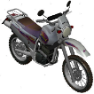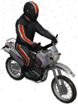
TT250R 1995 TT250R 1995
with driver

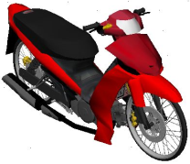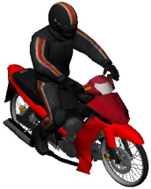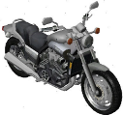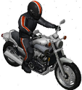
Vega ZR Vega ZR V-MAX V-MAX
with driver with driver

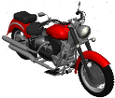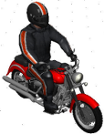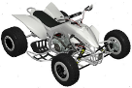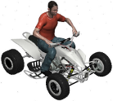
XV 1600 XV 1600 with driver YFZ 450 Quad YFZ 450 Quad with driver

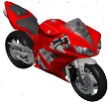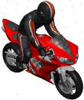
YZF R1 2004 YZF R1 2004 with driver

Nature:

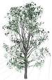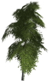
Birch Tree 5m Birch Tree 6m Bush 1m Cactus 2m

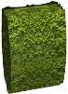
Eastern cotton wood 4m Grass 1m Hedge 2m

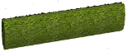
Hedge 3m Hedge 6m Hedge Thuja 2m Maple tree 10m Needle tree 4m

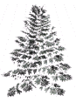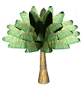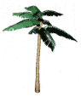
Needle tree 6m Needle tree 8m Palm 8m Palm 10m Palm 12m

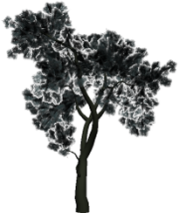
Pine tree 8m Tree 5m

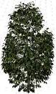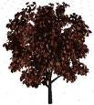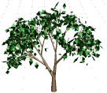
Tree 7m_01 Tree 7m_02 Tree 7m_03 Tree 7m_04 Tree 7m_05 Tree 8m_01

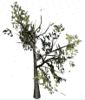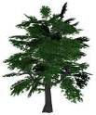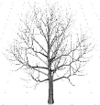
Tree 8m_02 Tree 10m Tree without leaves 5m

Nature > Trees Abstract:
Tree abstract 8m Tree abstract 12m Trees abstract 25m

Weitere Nature:
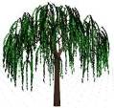
Willow 10m

Trailer:
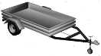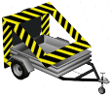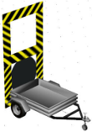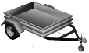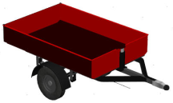
1-axle 1-axle construktion_01 1-axle construktion_02 1-axle short_01 1-axle short_02

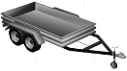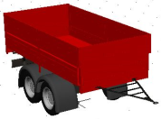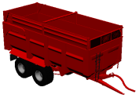
2-axle 2-axle 5.1m 2-axle 9m

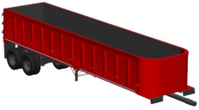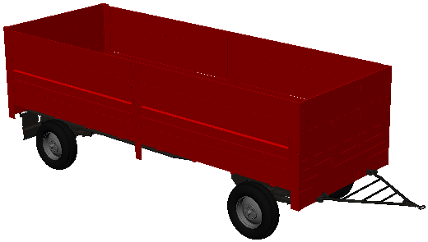
2-axle Dump Trailer 2-axle Dump Trailer B

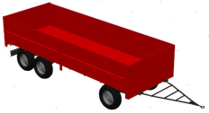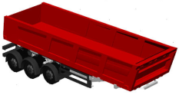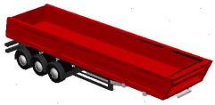
3_axle_6m 3_axle Dump Trailer 3_axle Dump Trailer long

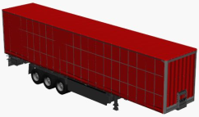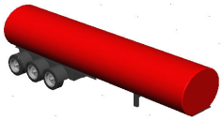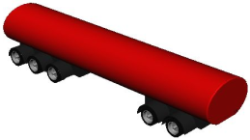
3_axles Krone 3_axles Tanker 5_axles Tanker

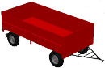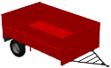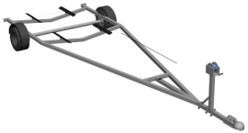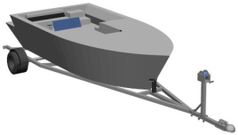
Agricultural trailer 5m Agricultural trailer 3.7m Boat Trailer Boat Trailer + Boat

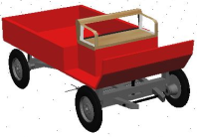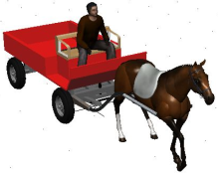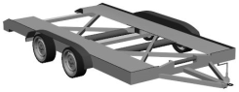
Buckboard Buckboard with horse Car trailer

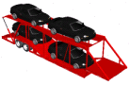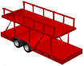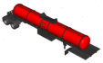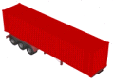
Carmover Cartrailer Supertrans Chemic Tanker Container Trailer

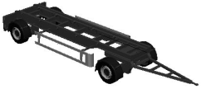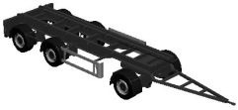
Container Trailer Container Trailer
2 axle 7m 3 axle 7m

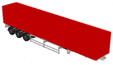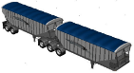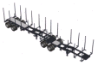
Daf 1700 Doepker Doepker logger

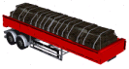
Double Trailer Double Trailer Dump Trailer Dust Container
3-axle Tanker

Fiat Roadtrain

Fiat Trailer Flat Flat loaded Horsetrailer

Joskin Trailer
3-axle

JTTRAIL Koegel SN24

Liquid manure tanker Liquid manure Liquid manure Livestock Trailer
tanker small_01 tanker small_02

Lowboy Mercedes Antos Moving
Tandem Trailer

Railcar Railcar_container Rear Carriage Refrigerator

Renault Magnum Schmitz 3-axle
Container Dump Trailer

Semitrailer 2-axle Semitrailer 3-axle Semitrailer 3-axle 9m Semitrailer 3-axle 14m

Special Trailer Tanker 4m Tanker 7,5m

Tanker 8,5m Tanker 10m Tanker 12,5m

Tanker 13,5m Trailer 5m_01 Trailer 5m_02

Trailer Box 8.2m Trailer Box 8.5m Trailer Box 9.5m

Trailer Waggon 8m Trailer Waggon 13m Viberti 2-axle 7.5m

WAB Semitrailer WAB Semitrailer
1-axle 2-axle

Trains: Auswahl über PC-Crash

Trams:
Trams > Tram Combination:
Tram front Tram front 9.3m Tram middle 4.5m Tram middle 6m Tram middle long

Tram middle short Tram rear Tram rear 9.3m

Weitere Trams:
Tram_01 Tram_02 Tram_03 Tram_04

Tram_05 Tram_06 Tram_07 Tram_08

Trikes:
Bajaj RE rickshaw Daihatsu Midget

Trikes > Piaggio:

Piaggio APE601 Piaggio APE_01 Piaggio APE_02 Piaggio APE_03 Piaggio APE_04

weitere Trikes:
Trike

Trucks:
8241 Airtug Ashok Leyland 2516

BerlietGBC cargo-truck Chevrolet C20
Towtruck

Concrete Mixer DAF Daf 1700 DAF CF

DAF Concrete Pumper DAF Fridge Daf XF 105_01

Daf XF 105_02 Daf XF 105_03 DAF XF 106 DAF XF 106
with contailner

DAF XF 480 Daf XF_01 Daf XF_02 Daf XF_03

Dodge Dumper Dump truck Dumper Fiat 4 axles

Fiat 50 NC Fiat Ducato Fiat Ducato Fiat Roadtrain Fiat_01
PanelVan III 2006 Pickup III 2006

Fiat_02 Ford Ford Cargo Ford E-Series
Box Truck

Ford F-150 Ford Freightliner Ford L8000 Ford Tanker
Campmobile

Ford Transit Ford Transit 2006 Ford Transit Pickup Ford Transit Pickup 2008 Ford Wrecker

Freightliner Freightliner Freightliner Freightliner FLD120
Classic XL Coronado Coronado DayCab

Freightliner M2 106 Box

Garbagetruck GAZ 52 GAZ 66 GAZ 2006 GAZon Next 2015

Heavytruck Hino Ranger Hyundai H100

IFA L60 IFA W50 Isuzu Forward 5 Isuzu Forward 5 Cargo Iveco Daily

Iveco Eurotech_01 Iveco Eurotech_02 Iveco Stralis Iveco Stralis 2x4 Iveco Stralis 3x6

Iveco Stralis Iveco Stralis
Garbage Truck Garbage Truck 2axle

Iveco Turbo Daily Kamaz 5410 Kenworth

Kenworth dump truck Kenworth K100_01 Kenworth K100_02 Kenworth T600_01

Kenworth T600_02 Kenworth W900 Kenworth W900 B

Kenworth W900 KrAZ 5133 LEYLAND
Cement Truck

Mack CH16 1993 Mack Dumper

Mack Pinnacle Mack Pinnacle Mack truck
CXU612 2012 CXU613 2012

MAGNUM MAN L2000 MAN TG Dump Truck

MAN TGL 8210_01 MAN TGL 8210_02 MAN TGM Platform MAN TGS18.320
Trash Truck
MAN TGX_01 MAN TGX_02

Mercedes Actros 2 Mercedes Actros Mercedes Actros
3axle 1863 2011

Mercedes Actros 3241 Mercedes Actros Dumper Mercedes Actros
Dumper 2_axle
Mercedes Actros Mercedes Antos Mercedes Arocs
Gas Tanker Dumper 2013
Mercedes Atego Mercedes Atego Mercedes Atego_02
1323L 2011

Mercedes Axor 2640 Mercedes Cartransporter Mercedes Econic 2013

Mercedes Sprinter Mercedes Sprinter Mercedes Sprinter
Car Transporter PanelVan 2006 Pickup 2000

Mitsubishi Colt_01 Mitsubishi Colt_02 Mitsubishi Fuso Mitsubishi Fuso Crane
Navistar Int. 9800 Nissan NT 500 2014

Peterbilt 340 DOM 2007 Peterbilt 351 Peterbilt 359

Peterbilt 385 2006 Peterbilt 387 Pickup Renault C280

Renault Magnum_01 Renault Magnum_02 Renault Magnum_03

Renault Midlum Renault Premium 6x2 Renault Premium 420

Scania 112 Scania 113 Topline Scania 113H Scania 124L

Scania 143 Scania 164 Scania 450 Dumpster Scania Cement Mixer

Scania P420 Dumper Scania R450 2017 Scania R 580_01 Scania R 580_02

Scania R620 Scania R730 2010 Scania R730 Box Truck 2010 Scania T142H

Scania topline Scania Torpedo 580 Semitruck Tata 1613

Tow truck Toyota Crane Toyota Dyna

Truck UAZ 3303 1985 Unimog 421 Unimog 421 Snow

Unimog U1700

Volvo F10 Volvo FH12_01 Volvo FH12_01 – Trailer Volvo FH12_02

Volvo FH16_01 Volvo FH16_02 Volvo FMX Volvo FMX Box Truck

Volvo FMX Dumper Volvo N10 Volvo N10_02

Volvo NH12 Volvo TH5 VW 23-310

VW Crafter Zil 131
PanelVan

